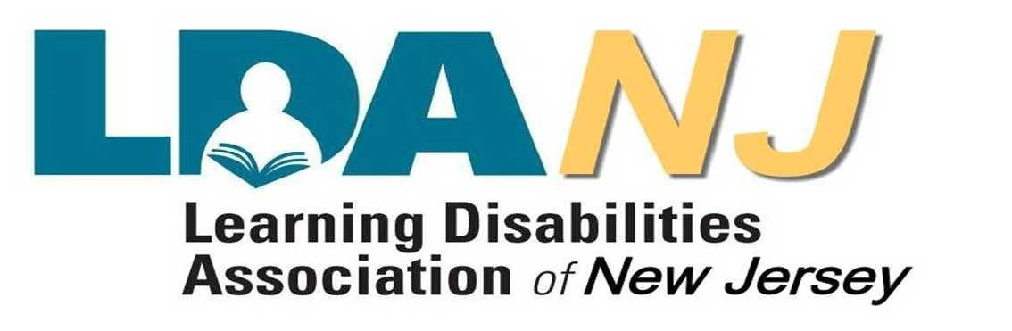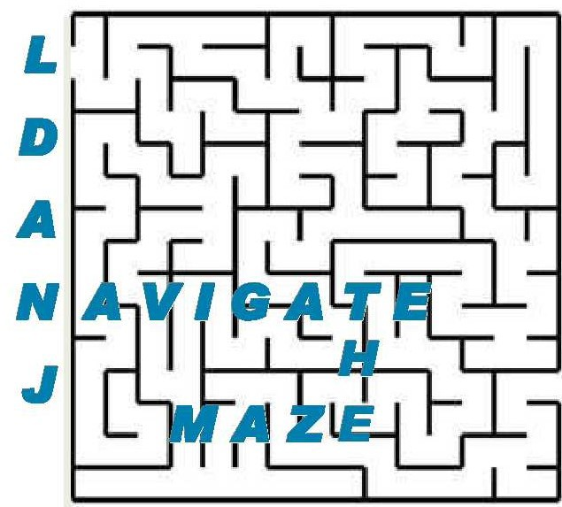
For Parents, Professionals, Students, & Community Members Interested in
Knowing More about Learning Disabilities and Attention Issues
Navigate the Maze Conference
Vendor & Post-Secondary Resource Expo
October 23, 2016
Livingston Campus Student Center, Rutgers University

8:00-8:45 Registration, Breakfast, & Resource Expo Open
8:45-10:15 Welcome & Keynote
- Meet LDA of America & LDANJ Educator of the Year – Nancy Hammill
- Busting the Myths and Stigmas around Learning and Attention Issues:
A Way Forward – Amanda Morin, Understood.org staff expert & writer
10:15-10:45 Networking & Resource Expo
10:45-12:15 Session 1
Workshop A: Dyslexia: Making it Personal
Workshop B: IEPs - More Than Just About Grades
Workshop C: Using Patterns of Strengths/Weakness to Differentiate Instruction
Workshop D: Resilience Can Be Taught! 10 Tools to Motivate Any Student
Workshop E: Successful Transition from High School to College for Students with LD
Workshop F: Mindfulness/Meditation to Deal with Anger, Frustration, and Stress
Workshop G: How to Engage Children and Keep Them Engaged So They Learn!
12:15-1:00 Lunch - Meet Drums & Disabilities
-Improving Achievement for ALL Students with NJTSS - NJ Dept. of Education
1:00-2:30 Session 2
Workshop H: Accommodations: Opportunity on the Playing Field
Workshop I: Diagnosing Decoding Issues in Students of All Ages
Workshop J: Vocabulary-The Key to the Kingdom
Workshop K: The Healing Art of Drum Therapy
Workshop L: ADHD & Learning Differences: Role of Neuropsychologist in Evaluation & Treatment
Workshop M: Striving for Success in Special Education with a Technology Toolbox
Workshop N: How Do I Self-Advocate? Insights and Strategies for College & Life
2:30-3:00 Networking & Resource Expo
3:00-4:30 Session 3
Workshop O: ADHD From the Inside Out: What's New, What's Not New, and What You Can Do
Workshop P: Language Needs and Program Decisions
Workshop Q: How to Advocate for Students with LD for Experts and Parents
Workshop R: Managing Challenging Behavior: an Overview of Collaborative & Proactive Solutions
Workshop S: What We Want Everyone to Know About Dyslexia
Workshop T: College and Work Success for All!
Workshop U: Linking Assessment to Intervention by Understanding the Academic Manifestations of
Cognitive Strengths and Needs
4:30 Certificates for 6 Professional Development hours will be available (NJ Provider Identification #568)

Full brochure and mail-in registration form available on www.ldanj.org. Go to Events.
For credit card registration go to www.ldanjOct23.eventbrite.com.
Cost is $25 members/students & $50 non-members. Questions? Call 732-645-2738 or email info@ldanj.org.

